RESUME
LULESWAR NARAH 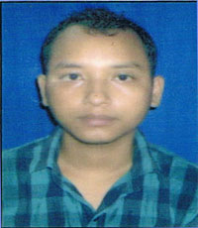
Contact No.-9508551602
Email-lulunarah1989@gmail.com

CAREER OBJECTIVES
To utilize best of my potential and experience in the field of Accounting and Banking, and also utilize my skills, in order to increase productivity of organization and individual growth. And intend to build a career with commitment and dedication, which will help create an atmosphere for potentiality, efficiency and elevation of the career.
SKILLS SETS
- Thorough knowledge of Banking and Accounting.
- Strong analytical, problem solving, organizational ability
- Written and communication skills
- Ability to deal with people diplomatically
- Willingness to learn
EDUCATION QUALIFICATION
- B.com with 61% marks from Dibrugarh University
- H.S.C. with 71% marks from Jawahar Navodaya Vidyalaya, North Lakhimpur
- Metric with 74% marks from Jawahar Navodaya Vidyalaya, Dhemaji
TECHNICAL SKILLS
- MS Office 2003, 2007, 2010
CERTIFICATION
- Tally & ERP
PROFESSIONAL DETAILS
- Working as Junior Accountant in Green Valley Travels Pvt. Ltd. Since 5th August 2016.
PERSONAL DETAILS
Date of birth- 14-07-1989
Language – Hindi, English, Assamese
Hobbies- Playing, watching movies, reading books
Address- vill Kulapathar, po- Aradhal, pin-787057 , Dist-Dhemaji (Assam)

DECLARATION
I hereby declare the above mentioned statements are true and best of my knowledge.

Date: Name: Luleswar Narah
Place:

